***Final Project - Phase I***

**Golan Regional Council Management Application**

By Guy Edri & Eldad Shneor  
Advisor: Dr. Naomi Unkelos Shpigel

Software Engineering Department  
Braude College of Engineering

Project Code: 24-2-D-17

[Project GitHub link](https://github.com/GuyEdri8/Golan-Project.git)



***Table of Contents***

***Abstract*** 3

***1.*** ***Introduction*** 4

***2.*** ***Literature Review*** 6

**2.1.** **Multi-Year Infrastructure Development (MYID)** 6

**2.2.** **Data-Driven Rural Management** 6

**2.3.** **Smart Villages and Digital Transformation** 7

**2.4.** **Rural Development Index and Evaluation Methods** 7

**2.5.** **User centered design** 8

***3.*** ***Research*** 9

**3.1.** **Interview overview:** 9

**3.1.1.** **Stakeholder Meeting:** 9

**3.1.2.** **Project Goals:** 9

**3.1.3.** **Ongoing Communication:** 9

**3.1.4.** **Data and Criteria Development:** 10

**3.2.** **Interviews Insights** 10

**3.3.** **Web Development Research** 11

**3.4.** **Research Summery** 11

***4.*** ***Software Engineering Process*** 13

**4.1.** **Design Process** 13

**4.2.** **System Architecture Overview** 14

**4.2.1.** **Architecture Diagram** 14

**4.3.** **Technologies Review** 15

**4.3.1.** **Client Side** 15

**4.3.1.1. Next.JS** .......................................................................................................................15

**4.3.1.2. TypeScript** ..................................................................................................................15

**4.3.1.3. Tailwind CSS** .............................................................................................................15

**4.3.1.4. Shadcn UI** ..................................................................................................................15

**4.3.1.5. Zustand** ......................................................................................................................15

**4.3.2.** **Server Side** 16

**4.3.2.1. Supabase** ....................................................................................................................15

**4.3.2.2. Auth.JS** .......................................................................................................................15

**4.3.2.3. PostgreSQL** ................................................................................................................15

**4.4.** **Mobile First Approach** 16

***5.*** ***Work Artifacts*** 17

**5.1.** **System Requirements** 17

**5.1.1.** **Functional Requirements** 17

**5.1.2.** **Non-Functional Requirements** 17

**5.2.** **Use-Case Diagram** 18

**5.3.** **Activity Diagrams** 19

**5.3.1.** **General Flow** 19

**5.3.2.** **Village Data Flow** 20

**5.3.3.** **Dashboard Progress** 20

**5.4.** **Application Screen Prototype** 21

**5.4.1.** **Mobile Screenshots** 22

***6.*** ***Expected Achievements*** 23

**6.1.** **Challenges** 23

**6.2.** **Success Criteria** 23

***7.*** ***Testing Plan*** 25

**7.1.** **Scope** 25

**7.2.** **Objectives** 25

**7.3.** **Testing Approach** 25

**7.4.** **Test Cases** 26

***8.*** ***Integration of AI Tools*** 30

**8.1.** **Leveraging Claude Sonnet 3.5 and ChatGPT 4o** 30

**8.2.** **Utilizing Copilot** 30

**8.3.** **Utilizing v0.dev** 30

***9.*** ***References*** 31

***10.*** ***Appendices*** 32

**10.1. First meeting with the Golan Regional Council board - Summary** 32

**10.2. Zoom meeting with Dovrat Marciano, the Golan Regional Council designated liaison – Transcript** 33

# ***Abstract***

This project presents the development of a digital rural management system for the Golan Heights regional council, aimed at modernizing their outdated processes. Currently, the council relies on numerous Excel and Word files, resulting in inefficient data management and organizational challenges. The proposed solution is a centralized digital platform that streamlines urban planning, data comparison visualization, and decision-making processes. Key features include data integration, automated reporting, and user-friendly interfaces for various uses.  
The system aims to improve operational efficiency, enhance data accuracy, and facilitate better-informed rural development decisions. This document outlines the design process, implementation challenges, and potential impact of the new digital system on the regional council's rural management practices.

# ***Introduction***

The Golan Regional Council, situated in the Golan Heights, northeastern of Israel, oversees the management of 33 towns[18]. Council employees are tasked with efficiently monitoring and managing various projects and processes within the council's jurisdiction.

A critical aspect of this management involves comparing data across different towns. However, the current system, relying on multiple Excel and Word files, has proven inefficient. This inefficiency stems from the cumbersome nature of handling numerous separate files, each containing data for individual towns. Employees must navigate through these files to gather information, a process that is time-consuming and prone to errors.

The lack of a centralized database makes it challenging to obtain a comprehensive overview of projects and processes across all towns simultaneously. Furthermore, the manual data entry required for each file increases the risk of inconsistencies and outdated information.  
Comparing data between towns becomes a laborious task, often requiring staff to open multiple documents side by side, manually extract relevant information, and compile it for analysis. This not only slows down decision-making processes but also increases the likelihood of overlooking crucial details. The system's limitations in facilitating real-time updates and collaborative editing further exacerbate these issues, potentially leading to miscommunication and inefficient resource allocation.

As the council strives to effectively manage its diverse array of towns, the need for a more integrated and streamlined data management solution becomes increasingly apparent.​​​​​​​​​​​​​​​​

The council has developed a comprehensive plan called PITARON. This five-year infrastructure development initiative aims to systematically enhance the Golan Heights' various facilities and services. Under this plan, each of the 33 villages within the council's jurisdiction is evaluated based on a diverse set of criteria. These evaluations result in calculated scores that reflect the condition of each village across different aspects, such as the state of community buildings, sewage systems, and other critical infrastructure components. Currently, these scores are stored in individual case files for each village, typically in the form of Word and Excel documents. When new infrastructure projects are proposed or initiated, these scores play a crucial role in determining priorities. The council uses this data to identify which villages have the most urgent needs, ensuring that resources are allocated efficiently and that development efforts are directed where they are most needed. However, the current file-based system for storing and accessing this vital information presents significant challenges in efficiently managing and utilizing this data for strategic decision-making.​​​​​​​​​​​​​​​​

Based on our initial meeting, four main requirements were identified:

1. Update the "Pitaron" program booklet according to established criteria.
2. Provide tools for goal evaluation and measurement, including progress tracking and data visualization
3. Aggregate council information from various sources to facilitate access to government resources
4. Create an inter-departmental interface for consolidated information viewing and data sharing.

These requirements guide our development of a tailored solution to address the Golan Regional Council's rural management challenges.

This project aims to develop an advanced management system that significantly streamlines data visualization and comparison processes. The proposed system will enable council employees to view data in a simplified and more efficient manner, easily compare information across different towns, effectively plan and monitor ongoing projects, and strategize for future initiatives. By implementing this digital solution, the Golan Regional Council seeks to enhance its operational efficiency, improve decision-making processes, and ultimately provide better service to the communities under its purview.

# ***Literature Review***

* 1. **Multi-Year Infrastructure Development (MYID)**  
     MYID is a comprehensive five-year strategy aimed at transforming rural areas by addressing a wide array of infrastructure challenges. This initiative prioritizes the enhancement of economic, social, security, and housing infrastructure, all designed to improve the quality of life for rural populations across the country. Drawing inspiration from the decentralization efforts in Ukraine [2], MYID seeks to foster regional autonomy while ensuring that national resources are allocated effectively at the local level.

Decentralization in Ukraine, as outlined by Davydenko et al. [2], demonstrates the potential of such strategies in rural development. Ukraine’s decentralization reforms, initiated to address regional disparities and inefficiencies in public service delivery, provide valuable lessons for MYID’s approach. By devolving fiscal and administrative powers to local governments, Ukraine aimed to empower rural communities to address their unique infrastructure needs more effectively, leading to a slowdown in rural population decline and a stabilization of rural employment rates. Similarly, MYID emphasizes local leadership in decision-making, ensuring that projects are tailored to the specific needs of each region, while benefiting from centralized coordination and funding.

Furthermore, the MYID strategy aligns with the concept of decentralization by focusing on the diversification of economic activities in rural areas, creating sustainable employment opportunities, and improving access to essential services such as healthcare, education, and transportation. Drawing from the successes and challenges faced in Ukraine, MYID aims to create resilient rural communities by ensuring that infrastructure development is not only top-down but also responsive to the grassroots level. By fostering local autonomy and encouraging active participation from rural residents, MYID intends to bridge the gap between rural and urban areas, reduce economic disparities, and support long-term sustainability in rural regions.

## **Data-Driven Rural Management**

The shift towards data-driven management in rural areas is becoming increasingly prevalent, representing a significant evolution in rural development strategies. While not explicitly mentioned in the Golan plan, such approaches, as explored by Cheng et al. [1], could potentially enhance the effectiveness of planning and development. These methods facilitate more informed decision-making and resource allocation in rural development projects.

Cheng et al. [1] propose a 7-layer framework for data integration in rural planning, addressing the challenges of distributed, multi-semantic, and multi-source data typical in rural contexts. This architecture enables the creation of a comprehensive data ecosystem that can support various aspects of rural management. It incorporates both data warehouse and real-time data integration methods, allowing for efficient handling of both stable, frequently accessed data and rapidly changing planning data. The integration of Geographic Information Systems (GIS) with Management Information Systems (MIS) is a crucial aspect, allowing for spatial analysis of socio-economic data and enhancing the understanding of rural dynamics.  
  
The benefits of this data-driven approach in rural development are numerous. It enhances decision-making by providing comprehensive, up-to-date data, allowing rural planners and managers to make more informed decisions based on empirical evidence. This leads to more efficient resource allocation, improved monitoring and evaluation of projects, and support for long-term strategic planning. Additionally, centralized data systems can enhance transparency in rural development processes, potentially increasing trust and participation from rural communities.

However, implementing such systems is not without challenges. Ensuring data quality and reliability, particularly in areas with limited technological infrastructure, remains a significant hurdle. There's also the need to bridge the digital divide in rural areas and build capacity at all levels to effectively use and interpret the data. Moreover, while data-driven approaches offer many benefits, they should be balanced with and informed by local, traditional knowledge and practices in rural areas. By carefully addressing these challenges, data-driven rural management approaches could significantly enhance the effectiveness of rural development initiatives.

## **Smart Villages and Digital Transformation**

The concept of Smart Villages has emerged as a key strategy for rural development. Zavratnik et al. [8] conducted a comprehensive review of Smart Village initiatives and digital transformation practices in rural areas. Their study emphasizes the importance of integrating local knowledge with digital innovations to address specific regional challenges and promote sustainable development.

## **Rural Development Index and Evaluation Methods**

To assess and prioritize development needs, a plan was developed that incorporates a scoring system similar to Rural Development Indices used in other countries. For instance, Davydenko et al. [2] used a Rural Development Index based on 14 indicators across economic, social, infrastructural, demographic, and employment dimensions. The Golan plan similarly considers factors such as population size, existing infrastructure, and specific community needs in its evaluation process [7]. This comprehensive approach aligns with the multi-dimensional nature of rural development, as highlighted in the Ukrainian study.

## **User centered design**

User-Centered Design (UCD) is a critical methodology for enhancing the effectiveness and efficiency of digital transformation efforts, especially in public services. A case study in Brazil [3] illustrates how UCD, by focusing on citizen involvement, can significantly improve the delivery and usability of digital services. The study applied UCD techniques through participatory design workshops, incorporating methods such as ethnography and design thinking, to address the needs of the Call-100 service, a hotline for reporting human rights violations. By involving users directly in the design process, the approach fostered a deeper understanding of the real challenges and expectations that citizens face when interacting with public services.

The findings of the study indicate that UCD leads to higher user engagement and awareness, as well as greater system efficiency and satisfaction among users. In particular, the inclusion of citizens in workshops helped generate practical solutions that reduced the complexity of interactions, minimized redundant processes, and ultimately lowered operational costs. Furthermore, UCD ensured that the digital channels provided by the government aligned more closely with user needs, offering improved accessibility and a more humanized user experience. This process not only motivated citizens to be more active participants in public services but also allowed the government to make better-informed decisions based on direct feedback from the population.

The success of UCD in this context underscores its importance in ensuring that technological solutions in the public sector are not only efficient but also user-friendly and responsive to real-world demands. This citizen-centered approach is crucial for building trust, improving the quality of digital services, and ensuring that public investments in technology genuinely enhance the well-being of citizens.

​

# ***Research***

Our research process involved several key components:

## **Interview overview:**

* + 1. **Stakeholder Meeting:** On July 15, 2024, we conducted a comprehensive meeting with the management of the Golan Regional Council. Participants included key figures from the council such as Yaakov Se Lavan (Deputy Chairman of the council), Muli Shpigel (Director of Engineering Department), Miki Menachem (Deputy Director of Operations), Golan Shemesh (Operations Department Manager), and Dovrat Marciano (Development and Strategy Coordinator), among others.  
       Key points from this meeting:
* The council currently lacks a comprehensive system for planning, control, and cross-sectional data presentation.
* There's a need for a "snapshot" view of data and the ability to extract information for meetings with various authorities.
* Rating keys are being developed to create criteria for each domain with relative weights.
* A system for managing and controlling all projects is needed for information sharing, prioritization, and ongoing process control.  
  + 1. **Project Goals:** Four main objectives were defined for the student project to be presented in September:
* Updating the booklet according to criteria for the "Pitaron" program.
* Evaluation and measurement of goals (showing progress rate, graphs, process transparency).
* Aggregation of council information from various sites to enable access to government resources and submission of calls for proposals.
* Inter-departmental interface for all departments and ability to view information consolidation for various bodies.  
  + 1. **Ongoing Communication:** We established a consistent line of communication    with Dovrat Marciano, the designated liaison for the Golan Regional Council. Through multiple conversations, including Zoom meetings, we were able to refine our understanding of the council's expectations and gather additional details crucial for the project's success. Key points from these discussions:
* The need for a system to manage and document public infrastructure.
* Definition of criteria for ranking settlements based on infrastructure and demographic characteristics.
* Discussion on the structure of the rating table for settlements, including what data and components should be included.
* The importance of developing clear criteria for rating different types of buildings and infrastructure.  
  + 1. **Data and Criteria Development:** It was emphasized that while some data exists, it needs to be better organized. There is a need to develop specific criteria for rating various types of buildings and infrastructure. This process will require time and collaboration between council members.

## **Interviews Insights**

* The council lacks a comprehensive system for planning, control, and data presentation across departments. There's no easy way to get a quick "snapshot" or extract specific data.
* Currently, each village maintains separate WORD and Excel files containing diverse information. To conduct cross-comparisons, staff must manually sift through 33 sets of these files, laboriously extracting and recording the desired data by hand. There's a pressing need for a system that can efficiently aggregate council information from these various sources to streamline regional council management and eliminate this time-consuming manual process.
* While the council manages numerous projects, they lack a system for planning, monitoring, and presenting data horizontally across projects.
* The system should provide the ability to view progress rates, display graphs, and ensure transparency in processes.
* The council is developing rating keys to create criteria for each domain with relative weights. There's a need for clear criteria to rank settlements based on infrastructure and demographic characteristics.

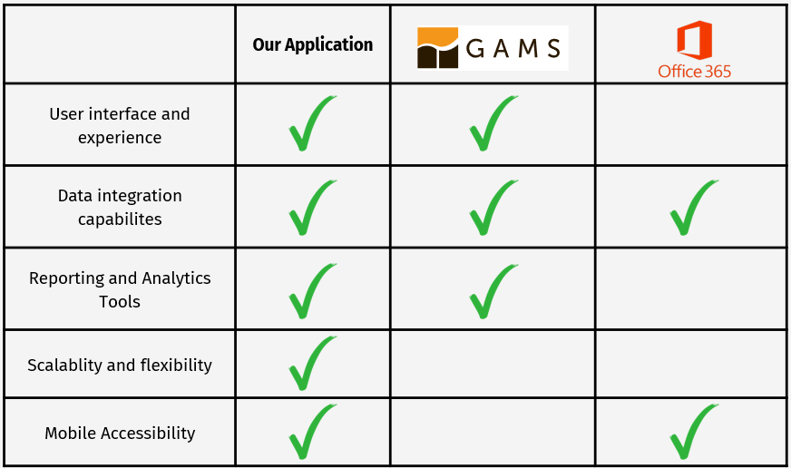

*Figure 1. Comparison chart to existing solutions*

## **Web Development Research**

After extensive consultations with key stakeholders, it became evident that there's an urgent need for a comprehensive, flexible, and accessible system to manage and visualize the "Pitaron" plan's infrastructure development projects. Based on these discussions, we've decided to leverage a modern web development stack to create a powerful, user-friendly web application.  
The web platform is designed to serve as an all-encompassing tool for council members. It will provide an intuitive interface for data visualization, project management, and decision-making processes crucial for coordinating complex infrastructure development across multiple settlements in the Golan Heights.

While working on the web platform we decided to focus on key features:

* Data Security and Authentication: We will implement secure, passwordless, role-based authentication, ensuring that only authorized personnel can access sensitive project information based on their department and role. This approach enhances security while maintaining user convenience.
* Advanced Data Visualization: To assist in decision-making, the platform will offer advanced data visualization tools. These tools will allow users to generate customizable dashboards, charts, providing a clear overview of ongoing projects. Users will be able to filter and analyse data according to specific parameters, making it easier to identify trends, track progress, and anticipate potential issues.
* User Experience and Accessibility: To ensure that the platform is user-friendly, we will prioritize intuitive design and accessibility. The interface will be easy to navigate, with clear instructions and help resources available to users. The platform will also be optimized for various devices, including desktops, tablets, and smartphones, allowing council members to access the system from anywhere at any time.

## **Research Summery**

The development of a web application for the Golan Regional Council aimed at enhancing rural management was informed by comprehensive research and stakeholder consultations. Key insights from a stakeholder meeting on July 15, 2024, highlighted the council's need for a unified system to improve planning, control, and data presentation across departments. The existing manual processes for data extraction and project management were identified as inefficient, leading to the definition of four primary project goals focused on updating criteria, evaluating goals, aggregating information, and improving interdepartmental communication.

Ongoing discussions with Dovrat Marciano, the council's liaison, further refined the project requirements, emphasizing the need for systems to manage public infrastructure, rank settlements, and ensure transparent project tracking. Data organization and the development of clear rating criteria were identified as crucial components for the project’s success.

In response to these needs, the web development research led to the decision to create a flexible and accessible web platform. Key features of this platform include secure, role-based authentication, advanced data visualization tools, and a user-friendly interface optimized for various devices. This platform will serve as a comprehensive tool for council members, enabling efficient management and visualization of infrastructure projects across the Golan Heights.

The Golan Heights plan categorizes its infrastructure components in a manner that mirrors these dimensions:

* Economic Infrastructure: This includes internet and electricity infrastructure, which support business development and overall economic growth.
* Social Infrastructure: Public service buildings and educational facilities fall under this category, enhancing community well-being and access to education.
* Physical Infrastructure: This encompasses security infrastructure, drainage and sewage systems, and transportation infrastructure, improving connectivity and basic services.
* Environmental Infrastructure: While not explicitly part of the Ukrainian RDI, the Golan plan includes environmental considerations, aligning with sustainable development principles.
* Demographic Considerations: The plan takes into account population size and growth projections when determining infrastructure needs.

By establishing these comprehensive infrastructure standards and evaluation methods, the Golan Heights plan seeks to ensure equitable development across different villages. The use of a structured index or scoring system, similar to the RDI, provides valuable insights into the progress and impact of the infrastructure development efforts in the Golan Heights region, allowing for data-driven decision-making and adaptive planning as the project progresses.

# ***Software Engineering Process***

## **Design Process**

Our design process for the Golan Regional Council Management application followed a user-centered, iterative approach that involved several key stages:

* **Requirements Gathering**: We began with comprehensive stakeholder interviews, including a key meeting on July 15, 2024, with council management. This helped us identify the core needs and pain points in the current system, such as the lack of a unified platform for planning and data presentation.
* **Research and Analysis:** We conducted a thorough literature review, examining academic journals, industry publications, and case studies related to rural management systems. This research informed our understanding of best practices and innovative solutions in the field.
* **Conceptualization**: Based on the gathered requirements and research insights, we developed initial concepts for the system architecture. We focused on addressing the four main objectives that were brought up in the Interview.
* **Technology Selection:** We carefully evaluated various technologies, ultimately selecting a stack that includes Next.js, Zustand, and Auth.js. This selection was based on the need for performance, development friendly, and alignment with modern development practices.
* **Mobile-First Design**: Recognizing the increasing importance of mobile access, we adopted a mobile-first design approach. This ensured that the application would be fully functional and user-friendly on smaller devices while scaling effectively to larger screens.
* **Prototyping**: In the final stage of our design process, we concentrated on developing visual representations of the system's architecture and user interface. This crucial step transforms our conceptual ideas into concrete designs, allowing stakeholders to interact with and evaluate the proposed system.

## **System Architecture Overview**

This system architecture describes a modern web application built using Next.js 14 as the core framework, providing a unified platform for both client-side and server-side development. On the client side, the application leverages React components styled with Tailwind CSS and enhanced by Shadcn/UI for a polished user interface. State management is handled by Zustand, offering a lightweight and flexible solution. The application is primarily written in TypeScript and JavaScript, ensuring type safety and improved developer experience.

User authentication and authorization are managed through Auth.js, providing secure access control. On the server side, Next.js 14 continues to play a central role, facilitating API routes for data operations. The backend is powered by Supabase, a robust PostgreSQL-based database framework, enabling efficient data storage and retrieval. This architecture combines cutting-edge technologies to create a scalable, performant, and developer-friendly web application stack.

### **Architecture Diagram**

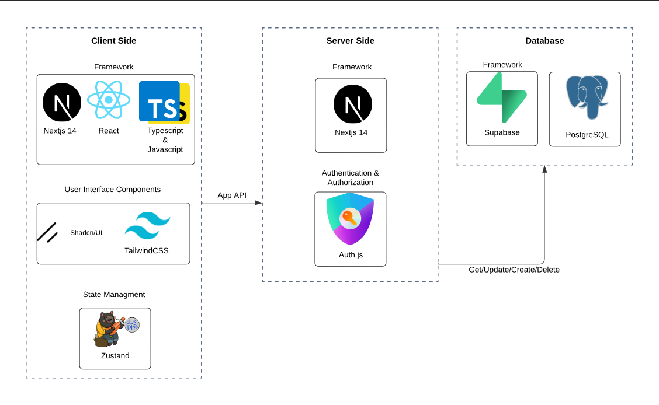

*Figure 2. Architecture Diagram*

## **Technologies Review**

### **Client Side**

#### **Next.JS**is a React framework that provides a robust set of features for building modern web applications. It offers server-side rendering for improved initial page load and SEO, static site generation for blazing-fast static pages, and automatic code splitting for optimal loading performance. Next.js also includes built-in CSS support, optimized asset handling, and API routes for creating serverless functions. Its seamless integration with platforms like Vercel makes deployment a breeze, enabling developers to focus on building great user experiences. [9]

#### **TypeScript** extends JavaScript by adding static types, which leads to early error detection during development and improved code readability. It essentially acts as self-documentation for your code, enhancing IDE support with better autocomplete and refactoring tools. This makes it easier to maintain large codebases and ensures compatibility with existing JavaScript code. By catching type-related errors before runtime, TypeScript significantly improves the overall quality and reliability of your application. [10]

* + - 1. **Tailwind CSS** is a utility-first CSS framework that allows for rapid UI development. It provides a comprehensive set of pre-built utility classes that can be composed to create custom designs quickly. Tailwind is highly customizable, allowing you to tailor the design system to your project's needs. It integrates PurgeCSS to minimize production CSS, includes responsive design utilities out of the box, and offers built-in dark mode support. These features combine to make Tailwind an efficient tool for creating polished, responsive user interfaces.[11]
      2. **Shadcn UI** is a collection of reusable UI components built on top of Radix UI and styled with Tailwind CSS. It provides accessible and customizable components that help maintain a consistent design language across your application. Shadcn UI integrates seamlessly with Next.js and Tailwind CSS projects, offering a set of well-designed, ready-to-use components that can significantly speed up development. With regular updates and community support, it's a valuable addition to any modern web development toolkit. [12]
      3. **Zustand** is a minimalistic state management library for React that offers a simple and intuitive API. Unlike more complex state management solutions, Zustand requires no boilerplate code and integrates easily with React hooks. Its small size and efficient update mechanism contribute to great performance. Zustand also includes built-in support for async actions and middleware, making it a flexible choice for managing application state in React projects of various sizes and complexities. [13]

### **Server Side**

#### **Supabase** is an open-source Backend-as-a-Service (BaaS) platform that provides a PostgreSQL database with real-time capabilities. It offers auto-generated APIs for database operations, built-in authentication and user management, and a storage solution for files and media. Supabase also includes serverless functions for custom backend logic, making it a comprehensive solution for building and scaling data-driven applications quickly and efficiently. [14]

#### **Auth.js**, formerly known as NextAuth.js, is a complete authentication solution for Next.js applications. It supports various authentication providers, including OAuth and email/password combinations. Auth.js handles secure, HttpOnly cookie sessions and offers both JWT and database session strategies. Its easy integration with Next.js API routes and customizable callbacks and events makes it a flexible and powerful tool for managing user authentication in Next.js projects.[15]

#### **PostgreSQL** is a powerful, open-source object-relational database system that plays a crucial role in our server-side stack. It provides robust data storage with support for complex queries, transactions, and excellent data integrity features. Its ability to handle large amounts of data and concurrent users makes it suitable for applications of various sizes. [16]

## **Mobile First Approach**

The Mobile First approach is a design and development strategy in software engineering that prioritizes creating the mobile version of a website or application before designing for larger screens. This methodology, introduced by Luke Wroblewski in 2009, has gained significant traction due to the increasing prevalence of mobile devices.

Key aspects of the Mobile First approach include:

* Prioritization: Focusing on core content and functionality essential for mobile users.
* Progressive enhancement: Starting with a basic mobile design and progressively adding features for larger screens.
* User-centric design: Addressing mobile users' needs and behaviours from the outset.
* Responsive design: Ensuring seamless adaptation to various screen sizes and devices.

By adopting a Mobile First approach, development teams can create more focused, efficient, and user-friendly applications that cater to the growing mobile user base while still providing a quality experience on larger devices.

# ***Work Artifacts***

## **System Requirements**

### **Functional Requirements**

1. The system will allow different users to log in with a username and password or log in with google.
2. The system will allow varying levels of access to different roles.
3. The system will provide an overview of key metrics and statistics related to urban management.
4. The system will provide notifications about recent activities.
5. The system will allow users to add, edit, and delete data related to each town.
6. The system will store and manage data such as population, infrastructure, budget, and ongoing projects.
7. The system will allow users to create, edit, and delete dashboards.
8. The system will enable users to compare data across multiple towns.
9. The system will Visualize comparisons using charts and graphs.
10. The system will allow users to create, edit, and track projects.
11. The system will allow to assign projects to different departments and set deadlines.
12. The system will provide a progress tracking feature for ongoing projects.
13. The system will allow to generate reports based on selected criteria (e.g., town performance, project status).
14. The system will allow to filter data based on different parameters (e.g., town size, project type).
15. The system will send notifications and alerts for upcoming deadlines, project updates, and important events.

### **Non-Functional Requirements**

1. The application must load within 2 seconds for the main dashboard. - **Performance**
2. The system should handle up to 500 concurrent users without performance degradation. - **Performance**
3. The application should be scalable to accommodate future growth in the number of users and data volume. - **Scalability**
4. The user interface should be intuitive and easy to navigate. - **Usability**
5. Implement automated backups and disaster recovery plans. - **Reliability**
6. The application should be compatible with major web browsers (Chrome, Firefox, Safari, Edge). - **Compatibility**
7. The application should be compatible for both desktop and mobile devices. - **Compatibility**
8. The system will support importing data from and exporting data to various formats (CSV, JSON, XML) for compatibility with other systems. – **Compatibility**
9. The system will support exporting reports to CSV/PDF format. – **Compatibility**

## **Use-Case Diagram**

* **User -** A regular employee of the Golan regional council with access to basic tasks like viewing village criteria and data.
* **Village Data Manager -** Responsible for managing and maintaining village data and criteria. Has the authority to edit data and manage dashboards.
* **Project Manager -** Manages projects, including creating, editing, and overseeing project details. Can generate reports and export data.
* **CEO -** The highest authority in the council, overseeing all operations. Has full access to all system features for decision-making and management.

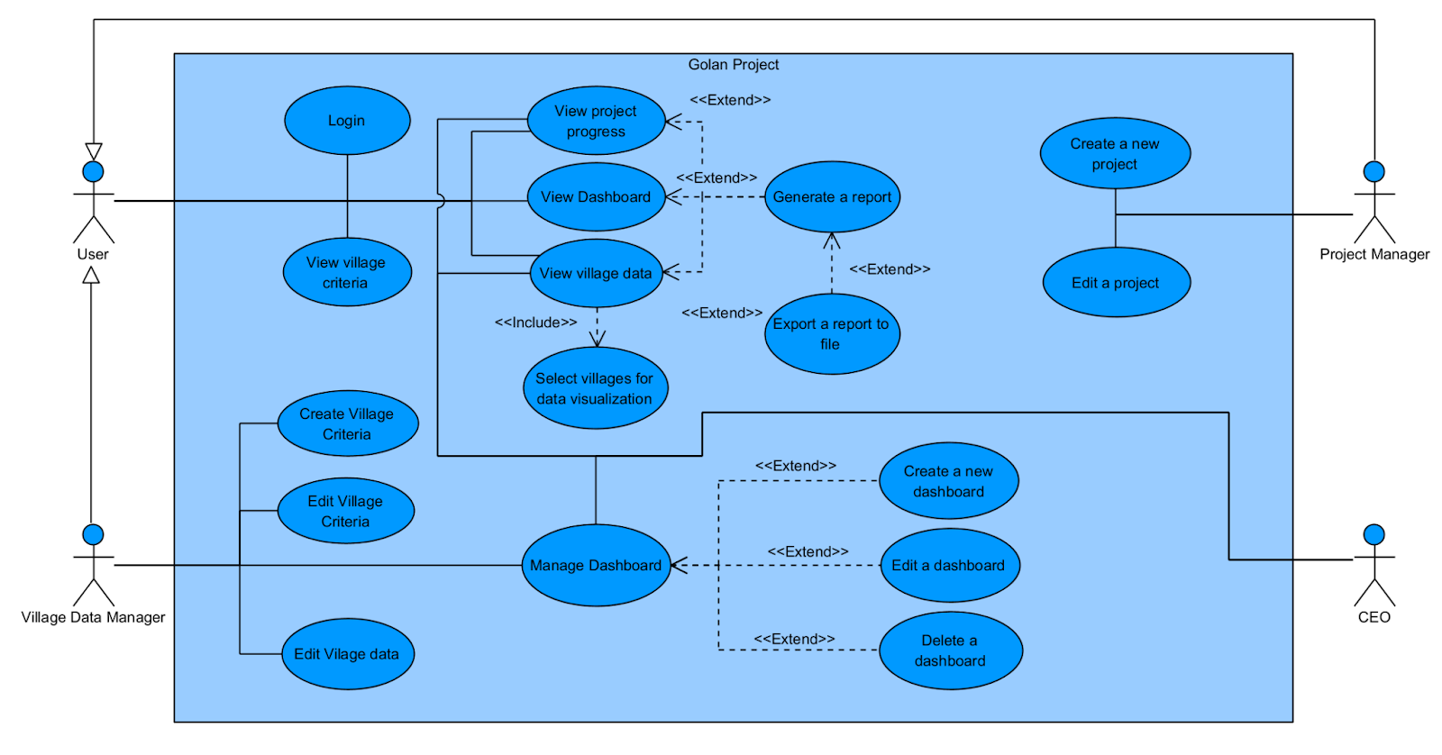

*Figure 3. Use-Case Diagram*

## **Activity Diagrams**

### **General Flow**

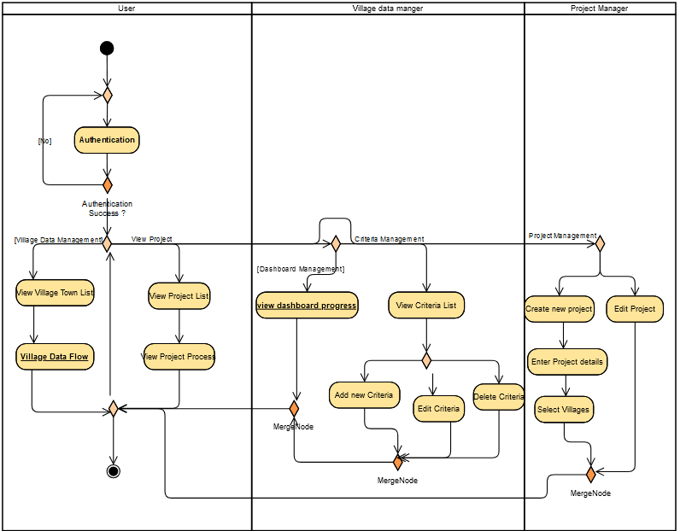

*Figure 4. Activity Diagram – General flow*

### **Village Data Flow**

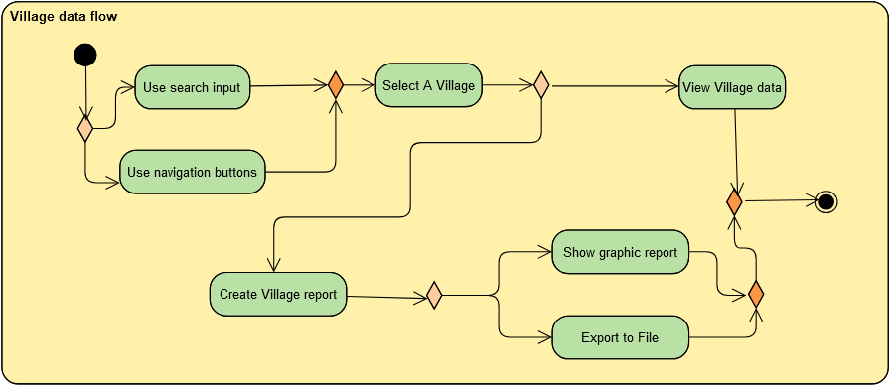

*Figure 5. Activity Diagram – Village Data flow*

### **Dashboard Progress**

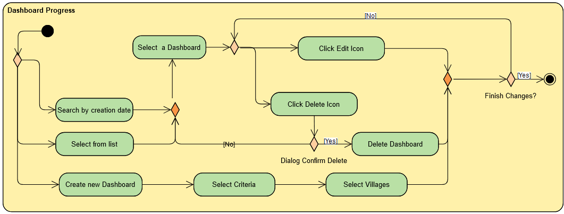

*Figure 6. Activity Diagram – Dashboard Process*

## **Application Screen Prototype**

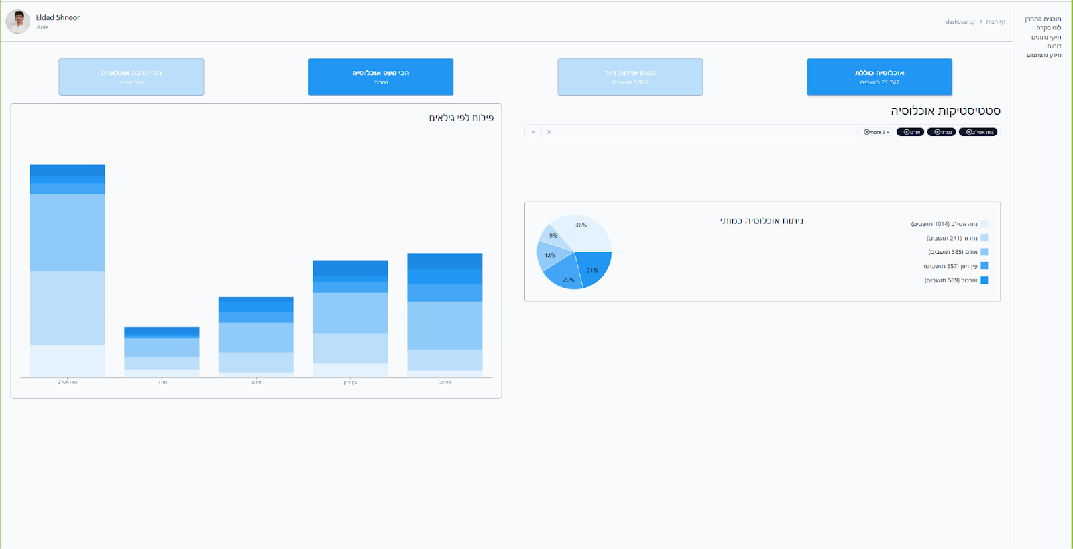

*Figure 7. Data comparison screen*

*Figure 8. Village case screen*

### **A screenshot of a computer Description automatically generatedMobile Screenshots**

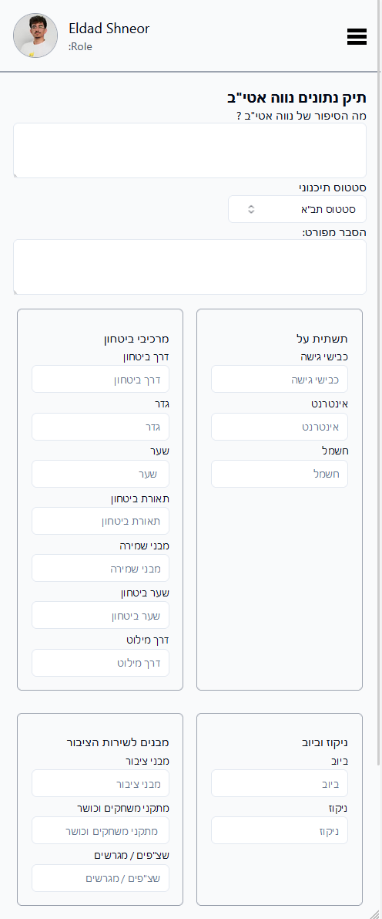

*Figure 10. Village case mobile screen*

*Figure 9. Data comparison mobile screen*

# ***Expected Achievements***

1. Development of a comprehensive web application for rural management.
2. Implementation of a digital system for updating the "Pitaron" program booklet.
3. Creation of a data aggregation tool to consolidate information from various council sources.
4. Establishment of an inter-departmental interface for improved communication and data sharing.

## **Challenges**

Throughout the project lifecycle, our team encountered several significant challenges:

1. **Evolving Criteria:** The villages' index criteria were still being developed as we started our work, complicating our planning process and initial project stages.
2. **Understanding User Needs:** In our first meeting with the regional council, we faced difficulties in clearly identifying their main issues with the current system and their specific needs for the new one.
3. **Workflow Redesign:** With the recent election of a new council, established work routines were not yet in place. This presented a unique opportunity for collaboration, allowing us to co-create innovative workflow processes tailored to the council's emerging needs.

## **Success Criteria**

1. System Functionality:

* Successful updating of the "Pitaron" program booklet through the application.
* Accurate aggregation of data from at least 90% of relevant council sources, with no discrepancies. A 90% threshold reflects the complexity of integrating various datasets while leaving room for gradual improvements.
* Effective interdepartmental information sharing capabilities, evidenced by a 30% reduction in manual cross-departmental communication.  
  Reducing manual communication by 30% shows the system’s ability to streamline processes and reduce redundancies.

1. User Experience:

* Intuitive interface for all council departments.
* NPS score [19] of 8 or above: An 8+ on a Net Promoter Score (NPS) survey is generally considered excellent. This target suggests the team wants strong positive feedback, indicating high satisfaction with the system's ease of use and functionality. It's ambitious but achievable, showing a commitment to quality user experience.

1. Data Management:

* Improved project tracking, with real-time visualizations of at least 80% of ongoing projects. Visualizing 80% of projects ensures comprehensive coverage, allowing project managers to monitor progress effectively.

1. Efficiency Improvements:

* Reduction in time spent on manual data compilation and sharing by 60%. Cutting manual processing time by 60% is a realistic target for optimizing the system’s capabilities.
* Increased speed in accessing relevant information for decision-making, with data retrieval times reduced by 40%. A 40% reduction reflects the system's efficiency in organizing and retrieving data, helping stakeholders make better, faster decisions.

1. Stakeholder Satisfaction:

* Meeting or exceeding the expectations of key stakeholders, including council management.
* Positive assessment from Dovrat Marciano, the project liaison.

1. System Integration:

* Seamless integration with existing council systems and workflows.
* 60% active users in alpha phase: Aiming for 60% active users during the alpha phase is a solid benchmark. It's high enough to indicate widespread adoption and engagement, but not unrealistically high for an early-stage rollout. This target balances ambition with the reality that some users might be hesitant to adopt new systems immediately.
* 70% of new projects managed within the system: Targeting 70% of new projects to be created and managed within the system shows a strong push for adoption. It's not 100%, allowing for some exceptions or special cases, but it's high enough to indicate that the system should become the primary tool for project management. This goal likely aims to drive a significant shift in work processes.
* Successful consolidation of information from various bodies (e.g., Kolhei Golan, Economic Company).

1. Scalability and Futureproofing:

* Ability to accommodate future expansion of features and data sources.
* Flexibility to adapt to evolving council needs and requirements.

# ***Testing Plan***

## **Scope**

Our testing strategy encompasses a comprehensive evaluation of web and mobile interfaces, backend functionalities, offline capabilities, and user interactions under simulated real-world conditions.

## **Objectives**

The primary objectives of our testing plan are to:

* Ensure all features function according to specification.
* Validate the user interface for ease of use and accessibility.
* Safeguard sensitive data through rigorous security testing.

## **Testing Approach**

We will implement Jest, a robust testing framework, for unit and integration testing across our application. Our strategy focuses on achieving high code coverage and setting specific testing metrics to enhance the application's overall quality and reliability. This approach aims to identify and rectify potential issues early in the development process.

To complement Jest [18], we will employ both automated and manual testing techniques. Automated testing will simulate user interactions, while manual testing will evaluate real-world scenarios.

For end-to-end (E2E) testing, we will utilize Cypress [17], a powerful and developer-friendly testing tool. Cypress will allow us to write and run tests that simulate real user scenarios, interacting with our application as an actual user would. This will help us verify that all parts of the application function correctly together in a production-like environment.

These combined methods will provide a comprehensive evaluation of the application's functionality, performance, and stability across diverse use cases, ensuring a robust and user-friendly final product.

## **Test Cases**

|  |  |  |  |  |
| --- | --- | --- | --- | --- |
| **Test area** | **Test name** | **Description** | **procedure** | **expected result** |
| Authentication | Magic Code - Login Successful | Verify that a user can successfully log in using the magic code method | 1. Navigate/redirect to the login page  2. Enter a valid email address  3. Click "Continue" button  4. Retrieve the magic code (simulating email receipt)  5. Enter the received magic code  6. Click "Sign in" button | User is successfully authenticated and directed to the main dashboard |
| Unregistered User Email | Verify system behaviour when an email not associated with any user account is entered | 1. Navigate to the login page  2. Enter a valid email format but one that doesn't exist in the users database  3. Click "Continue" button | System displays a message indicating that no account is associated with this email |
| Incorrect Magic Code | Verify system response when an incorrect magic code is entered | 1. Navigate to the login page  2. Enter a valid email address  3. Click "Continue" button  4. Enter a incorrect code  6. Click "Sign in" button | System displays an error message indicating incorrect code and prompts user to try again |
| Magic Code Expiration | Verify that a magic code expires after a set time period | 1. Navigate to the login page  2. Enter a valid email address  3. Click "Continue" button  4. Wait for the code expiration period ( more than 5 minutes) 5. Enter the expired code  6. Click "Sign in" button | System displays an error message indicating the code has expired and prompts user to request a new code |
| Social Login - Invited User | Verify that an invited user can successfully log in using their Provider account (Google/ Microsoft) | 1. Navigate to the login page  2. Click on "Login with Google/Microsoft" button  3. Select the Google/Microsoft account associated with the invited email  4. Authorize the application (if required) | User is successfully authenticated and directed to the main dashboard |
| Social Login - Uninvited User | Verify system behaviour when an uninvited user attempts to log in with a social account | 1. Navigate to the login page  2. Click on a social login option (e.g., "Login with Google")  3. Authenticate with a social account not associated with an invited email | System displays a message indicating that access is restricted to invited users only |
| Invitation Acceptance | Verify that a newly invited user can set up their account | 1. Send an invitation to a new user's email  2. User clicks on the invitation link in the email  3. User enters required information  4. User submits the information | New user account is created, and user is directed to the main dashboard |
| Invitation Expiration | Verify that invitations expire after a set period | 1. Send an invitation to a new user's email  2. Wait for the invitation expiration period  3. User attempts to use the expired invitation link | System displays a message indicating the invitation has expired and prompts to contact the administrator for a new invitation |
| Data Visualization | View Town Data | Test the functionality of viewing data for a specific town | 1. Login as a registered user  2. Navigate to the town data section  3. Select a town from the list | The town's data is displayed correctly with all relevant metrics visible |
| Project Management | Add New Project | Test the ability to add a new urban development project | 1. Login as a Project Manager  2. Navigate to the projects section  3. Click "Add New Project"  4. Fill in project details  5. Click "Save" | The new project is successfully added and listed in the projects section |
| Role-Based Access Control | CEO Dashboard Access | Verify that only the CEO can access the CEO-specific dashboard | 1. Login as a CEO  2. Attempt to access the CEO dashboard | The CEO is granted access to the CEO dashboard. Other roles should be denied access |
| Data Comparison | Compare Towns Data | Test the functionality for comparing data between two towns | 1. Login as a Village Data Manager  2. Navigate to the data comparison section  3. Select two towns for comparison | A comparison chart/table is generated, displaying the selected metrics for both towns |
| User Interface | Responsive Design | Test the responsiveness of the application on different devices | 1. Access the application on a desktop, tablet, and mobile device  2. Navigate through various sections on each device | The application adjusts correctly to different screen sizes, maintaining usability and design consistency |

# ***Integration of AI Tools***

## **Leveraging Claude Sonnet 3.5 and ChatGPT 4o**

Throughout the Literature Review and R&D phases. We employed both Claude [22] and ChatGPT [21]. We used identical prompts for each and compared their outputs, selecting the most precise responses. Some examples of our prompts include:

* Rephrase the provided paragraph for an article.
* Translate the given document into English.
* Create a table comparison between React and Vue and Angular state potential backend options within it.
* Give me feedback for this UML diagram and provide an example.

## **Utilizing Copilot**

We utilized Copilot in two distinct ways during the Literature Review and Initial Prototype Development:

* To produce summaries of articles when searching for topic-relevant literature.
* To explore various code snippet alternatives during the development process.

## **Utilizing v0.dev**

While creating our first prototype, we turned to v0.dev to design a bespoke UI component for the Golan Heights section.

Sample prompt:

“Design a layout page incorporating the following hex colors: '#e3f2fd', '#bbdefb', '#90caf9', '#42a5f5', '#2196f3', '#1e88e5', '#1976d2”

# ***References***

[1] Cheng, W., Wei, W., & Zhang, F. (2013). Research and Design of Data Integration   
 Architecture for Rural Planning. *Springer Link*.

[2] Davydenko, N., Wasilewska, N., Boiko, S., & Wasilewski, M. (2022). Development of   
 Rural Areas in Ukraine in the Context of Decentralization: An Empirical Study. *ResearchGate*.

[3] Glauco, P., Marcelo, J., Andrea, J., Leonardo, A., Fabiola, F., Rejane, F. (2022).   
 Applying User-Centered Design on Digital Transformation of Public Services: A Case   
 Study in Brazil. *Dl-ACM.*

[4] Khomiuk, N., & Pavlikha, N. (2023). Management of sustainable inclusive rural   
 development projects. *Scientific Repository of Lesya Ukrainka Volyn National   
 University*.

[5] Pluto-Kossakowska, J., Fijałkowska, A., Denis, M., Jaroszewicz, J., & Krzysztofowicz,   
 S. (2022). Dashboard as a Platform for Community Engagement in a City   
 Development—A Review of Techniques, Tools and Methods. *MDPI*.

[6] Tomashuk, I. (n.d.). Problems and prospects of management of rural development.   
 *CyberLeninka*.

[7] Yudha, E. P., Juanda, B., Kolopaking, L. M., & Kinseng, R. A. (2021). Rural   
 development policy and strategy in the rural autonomy era. Case study of   
 Pandeglang Regency - Indonesia. *Scientific Scholar*.

[8] Zavratnik, V., Kos, A., & Stojmenova Duh, E. (2018). Smart Villages: Comprehensive   
 Review of Initiatives and Practices. *MDPI*.

[9] [Next.JS Documentation](https://nextjs.org/docs)

[10] [TypeScript Documentation](https://www.typescriptlang.org/docs/handbook/typescript-in-5-minutes.html)

[11] [Tailwind CSS Documentation](https://tailwindcss.com/docs/installation)

[12] [Shadcn UI Documentation](https://ui.shadcn.com/docs)

[13] [Zustand Documentation](https://zustand.docs.pmnd.rs/getting-started/introduction)

[14] [Supabase Documentation](https://supabase.com/docs)

[15] [Auth.JS Introduction](https://authjs.dev/getting-started)

[16] [PostgreSQL Documentation](https://www.postgresql.org/docs/)

[17] [Cypress Documentation](https://docs.cypress.io/guides/overview/why-cypress)

[18] [Jest Documentation](https://jestjs.io/docs/getting-started)

[19] [Golan Regional Council official website](https://www.golan.org.il/ramathagolan/)

[20] [NPS Score](https://en.wikipedia.org/wiki/Net_promoter_score)

[21] [ChatGPT](chatgpt.com)

[22] [Claude AI](claude.ai/new)

# ***10. Appendices***

## **10.1. First meeting with the Golan Regional Council board - Summary**

**Date:** 15/07/2024

**Participants:**

Yaacov Se Lavan - Deputy chairman of the Golan Regional Council.

Muli Shpigel – Director of Engineering Department.

Miki Menahem – Deputy Director of Operations.

Golan Shemesh – Operations Department Manager.

Dovrat Marciano – Development and Strategy Coordinator.

Tal Nadler – Information Systems Manager.

Esti Zisman - Deputy Treasurer of the Council.

Raya David - Project manager in the engineering department.

Naomi Unkelos Shpigel - Project moderator

Eldad Shneor - Software Engineering student

Guy Edri - Software Engineering student

**Background and Main Points:**

1. Currently, the council undertakes numerous projects but lacks a system for planning, monitoring, and displaying data comprehensively. Each village has a dedicated WORD file containing information across various aspects (expansion progress/drainage/sewage/public buildings/sports fields).
2. At present, there is no way to view an "overall picture" or retrieve data in preparation for a meeting with the drainage authority.
3. Ranking keys are currently being developed to create criteria for each area and assign them relative weight. This work is ongoing and is expected to be completed by September.
4. A system for managing and monitoring all projects—there is a need for a system to share information and create prioritization and ongoing monitoring of all processes. This might be implemented in the second phase. We are also considering the integration of Office 365 for task management.
5. As part of the collaboration between the academic college and the council, several criteria have been defined that we wish to incorporate into the system being developed by the students, which will serve the council in advancing the Pitaron program.

For this purpose, we have set four goals for this project, which will be presented in the students' project in September (initial implementation as a Working Prototype):

* Update the manual according to the criteria for the Pitaron program.
* Evaluation and measurement of objectives (including progress tracking, graph presentation, and process transparency).
* Aggregation of council information from various sources, enabling the acquisition of government resources and submission of public tenders.
* An interdepartmental interface for all departments, providing the ability to view consolidated information for various entities (Kolhey Golan, Local Economic Corporation, Council).

**Tasks to be completed:**

* Tal Nadler: Check whether materials can be transferred to the academy in terms of information security.
* Students, Naomi: Take the criteria and integrate them into the system, so they can be presented to us in September, after which we can decide on the next steps (the system is open-source).

## **10.2. Zoom meeting with Dovrat Marciano, the Golan Regional Council designated liaison – Transcript**

**Date:** 08/08/2024

**Participants:**  
Dovrat Marciano - Development and Strategy Coordinator.  
Guy Edri - Software Engineering student.  
Eldad Shneor - Software Engineering student.

**Eldad Shneor's Meeting**

**Establishing a Public Infrastructure Management System**Discussion on building a system for managing and documenting public infrastructure, including setting criteria and presenting examples of the user interface.

Presentation of the planned system structure, including types of public infrastructure and the data that will be included. **12:20**

Explanation of the five criteria that make up the overall infrastructure score and how they are calculated. **13:43**

Presentation of an example table containing various data and scores, and an explanation of how they can be analysed. **15:41**

**Coordination of a Preparation Meeting for Training Discussion**Discussion on the need to hold a preparation meeting ahead of the training discussion, including confirming participants and coordinating with relevant parties.

Request to hold a preparation meeting with Avital and other people, and obtaining approval from the manager for this. **19:33**

**Defining Criteria for Ranking Settlements**The need to define clear criteria for ranking settlements according to infrastructure and demographic characteristics in order to set budgetary priorities.

The need to define clear criteria for ranking settlements according to infrastructure and demographic characteristics. **26:12**

The idea of defining criteria such as standard size by the number of children and classifying according to gaps between the settlements. **27:18**

The possibility of classifying settlements by upper/lower percentile or median, in order to set budgetary priorities. **28:06**

**Defining Data and Components for the Ranking Table**The need to define the data and components to be included in the ranking table of the settlements, such as demographic data and infrastructure.

The need to define the data to be included in the table, such as the number of residents, settlement clubs, etc. **26:24**

The need to define the criteria and how the scores will be calculated for each component in the table. **26:44**

The need to define criteria for infrastructure such as internet access, electricity, etc., and decide if there is a need to create them anew. **37:46**

**The Presented Table for Ranking Settlements**The need to understand the structure and data of the table presented for ranking settlements and decide how to use it optimally.

The table sent by Dovrat is a draft, but it can be used as a basis for work. **29:00**

The need to understand if the presented table is the relevant one for work or if a new table needs to be created. **31:40**

Suggestion to use the centralized club table as a basis and add the relevant data and criteria to it. **32:10**

**Work Process on the Ranking Table**The need to define the work process on the ranking table to ensure efficiency and prevent the need for later changes.

Suggestion to work on an initial framework of the table and then add the relevant data and criteria. **32:25**

The need to plan the work efficiently to avoid the need for later changes. **33:14**

The need to decide whether to present two options for the table to receive feedback and decide on the final version. **36:00**

**Presentation of Data and the Need for Clear Criteria**The discussion focuses on presenting the existing data and the need to develop clear criteria for ranking the various structures.

Dovrat presents the existing data and notes that they are not sufficiently organized. **40:37**

Dovrat explains that she would prefer to present the data in a more organized manner. **41:23**

Dovrat suggests calculating scores for each type of structure separately to present the data in a more organized manner. **42:22**

Eldad understands Dovrat's idea but notes that there is still a lot of work to develop specific criteria. **45:07**

**The Need for Developing Criteria and Timelines**The discussion focuses on the need to develop clear criteria for ranking the structures, taking into account the required timelines.

Eldad notes that currently, there are no clear criteria for ranking the specific points, and they will need to develop them. **46:16**

Eldad asks if Dovrat can try to create general criteria or if they will need to postpone development until September. **46:56**

Dovrat notes that she will work with Yaakov on developing the criteria but emphasizes that they need working time. **47:32**

Dovrat suggests working only on what they have now and developing another option later, depending on the feedback. **48:00**

**Agreement on the Use of Existing Data**The discussion focuses on the agreement to use the existing data, clarifying that they are not final.